

**FACULTY OF COMPUTER SCIENCE AND INFORMATION**

**TECHNOLOGY**

**WEB DEVELOPMENT**

**BIC 21203 S7**

**SEMESTER 2 2024/2025**

**TITLE: LAB 11&LAB ASSIGNMENT 4   
  
SERVER SIDE SCRIPTING**

|  |  |
| --- | --- |
| **Matric Num.** | **Name** |
| CI230083 | AHMAD NUR HABIB BIN MOHD SIDEK |

**The Solution**

**1. Overview**

This report documents the development of a **dynamic web application** that visualizes domestic tourism expenditure data (2010-2011) using **PHP, MySQL, and Chart.js**.

**2. Key Features**

* **Interactive dashboard** with three tabs:
  1. **Domestic Visitors**
  2. **Domestic Tourists**
  3. **Comparative Analysis**
* **Data visualizations**:
  1. Bar charts (yearly comparison)
  2. Pie charts (expenditure distribution)
  3. Radar chart (growth rate comparison)
* **Dynamic insights**: Automatically calculated growth rates and totals.

**3. Snapshots of the Solution**

**Snapshot 1: Domestic Visitors Expenditure**

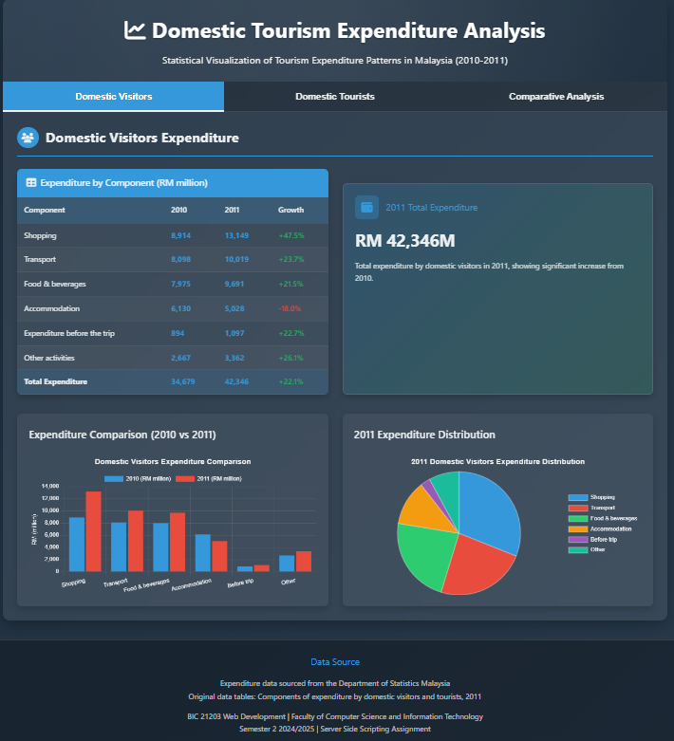

**Snapshot 2: Domestic Tourists Expenditure**

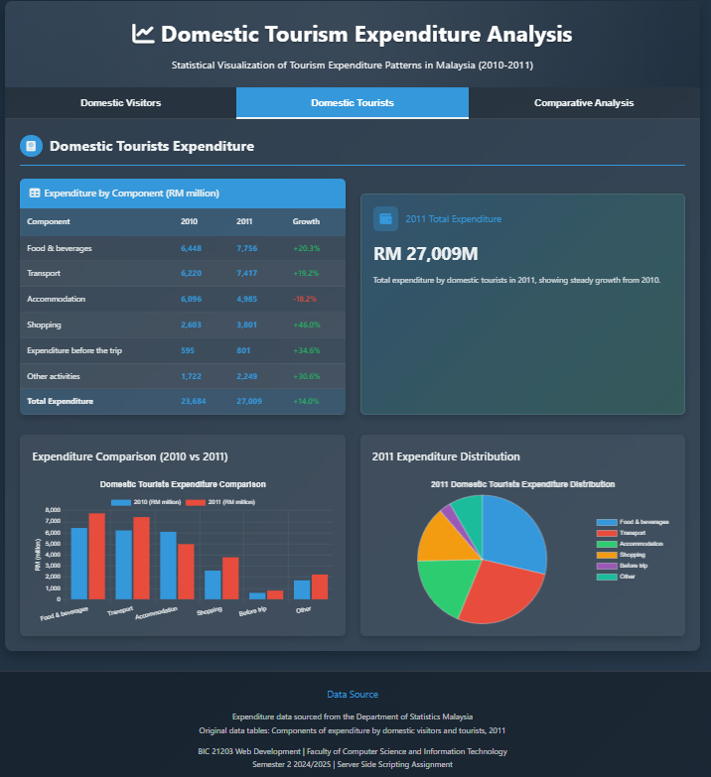

**Snapshot 3: Comparative Analysis**

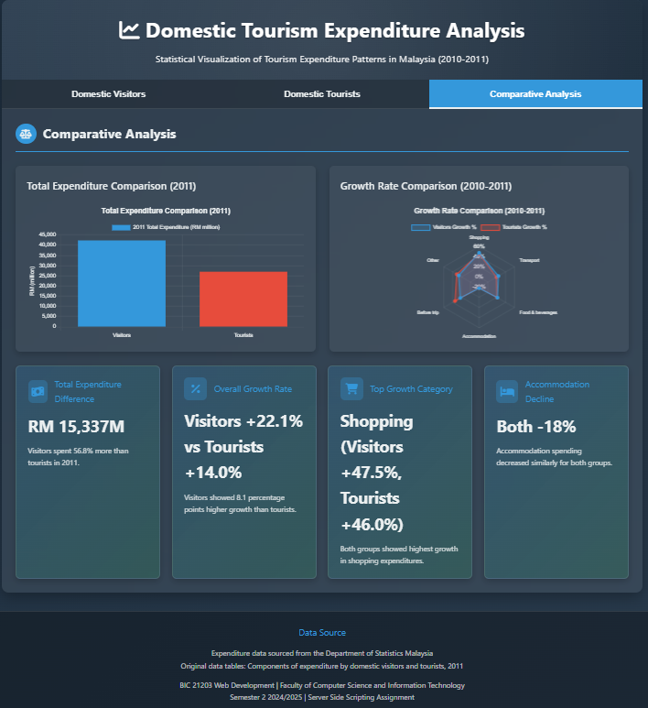

**4. Code Implementation**

**Key PHP Code (Data Fetching)**

php

// Fetch domestic visitors data

$sql_visitors = "SELECT * FROM domestic_visitors";

$result_visitors = $conn->query($sql_visitors);

$visitors_data = [];

while ($row = $result_visitors->fetch_assoc()) {

$visitors_data[] = $row;

}

**JavaScript (Chart Initialization)**

javascript

// Radar Chart for Growth Rate Comparison

new Chart(document.getElementById('growthChart'), {

type: 'radar',

data: {

labels: ['Shopping', 'Transport', 'Food', 'Accommodation', 'Before Trip', 'Other'],

datasets: [

{

label: 'Visitors Growth %',

data: [47.5, 23.7, 21.5, -18.0, 22.7, 26.1],

backgroundColor: 'rgba(52, 152, 219, 0.2)'

},

{

label: 'Tourists Growth %',

data: [46.0, 19.2, 20.3, -18.2, 34.6, 30.6],

backgroundColor: 'rgba(231, 76, 60, 0.2)'

}

]

}

});

**HTML (Tab Structure)**

html

<div class="tabs">

<button class="tab-btn active" data-tab="visitors">Domestic Visitors</button>

<button class="tab-btn" data-tab="tourists">Domestic Tourists</button>

<button class="tab-btn" data-tab="comparison">Comparative Analysis</button>

</div>

**SQL TABLE**

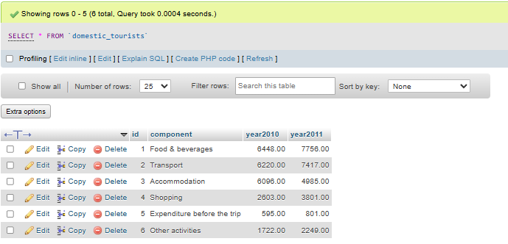

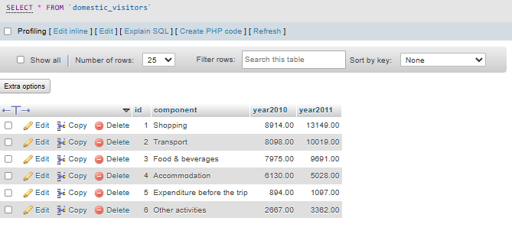

**5. Description of the Solution**

1. **Database Integration**:
   * MySQL tables store expenditure data for visitors and tourists.
   * PHP fetches and processes this data dynamically.
2. **Visualization**:
   * **Chart.js** creates interactive charts:
     + **Bar charts** compare 2010 vs. 2011 expenditures.
     + **Pie charts** show spending distribution.
     + **Radar chart** highlights growth rate differences.
3. **User Interface**:
   * **Tab system** for easy navigation.
   * **Responsive design** works on desktops and mobiles.
   * **Insight cards** summarize key findings (e.g., "Visitors spent 56.8% more than tourists").

**Summary & Conclusion**

**What I Learned**

1. **PHP + MySQL Integration**:
   * Practiced fetching data from databases and processing it for web display.
2. **Data Visualization**:
   * Used Chart.js to transform raw numbers into understandable charts.
3. **Frontend-Backend Workflow**:
   * Connected backend (PHP/MySQL) with frontend (HTML/JS) seamlessly.

**Difficulties Faced**

1. **Chart Configuration**:
   * Initially struggled with Chart.js options (e.g., radar chart scales).
   * Fixed by studying documentation and experimenting.
2. **Dynamic Calculations**:
   * Automating growth rate % required careful PHP logic.

**Skills Improved**

* **Backend Development**:
  + Better at writing efficient SQL queries and PHP scripts.
* **Data Storytelling**:
  + Learned to highlight key insights (e.g., "Accommodation spending decreased by 18%").
* **Debugging**:
  + Used browser consoles and PHP error logs to troubleshoot issues.

**Final Thoughts**

This project demonstrated how **server-side scripting (PHP)** and **data visualization (Chart.js)** can turn raw statistics into actionable insights. The biggest takeaway was understanding how to make data **interactive and user-friendly** on the web.

**Future Improvements**:

* Add export functionality (e.g., save charts as PNG).
* Include more years of data for trend analysis.